

School of Computing

SRM IST, Kattankulathur – 603 203

**Course Code: 18CSS202J**

**Course Name: Computer Communication**

|  |  |
| --- | --- |
| **Experiment No** | 10 (CC Mini Project) |
| **Title of Experiment** | Fire Prevention System |
| **Name of the candidate** | Shaurya Srinet |
| **Team Members** | Shounak Chandra |
| **Register Number** | RA2111032010006, RA2111032010026 |
| **Date of Experiment** |  |

**Aim:** To build a fire prevention system for a parking lot

# Components Required:

|  |  |
| --- | --- |
| **Devices** | **Required No.** |
| Server – PT | 1 |
| Access Point - PT | 1 |
| Sprinkler (IOT) | 1 |
| Smoke Detector (IOT) | 1 |
| Siren (IOT) | 1 |
| Window (IOT) | 1 |
| Old Car (IOT) | 5 |

**Addressing Table:**

|  |  |  |  |  |
| --- | --- | --- | --- | --- |
| **Name** | **Interface** | **IP Address** | **Subnet Mask** | **SSID** |
| Server0 | Fa0/0 | 192.168.1.1 | 255.255.255.0 | - |
| Access Point0 | Fa0/0 | - | - | Cisco |
| Sprinkler | Wireless | 192.168.1.2 | 255.255.255.0 | - |
| Smoke Detector | Wireless | 192.168.1.3 | 255.255.255.0 | - |
| Alarm | Wireless | 192.168.1.5 | 255.255.255.0 | - |
| Window | Wireless | 192.168.1.4 | 255.255.255.0 | - |

# Procedure:

**Step 1:** Drag all the required components (Server, Access Point, Sprinkler, Smoke Detector, Siren, Door) in the console area.

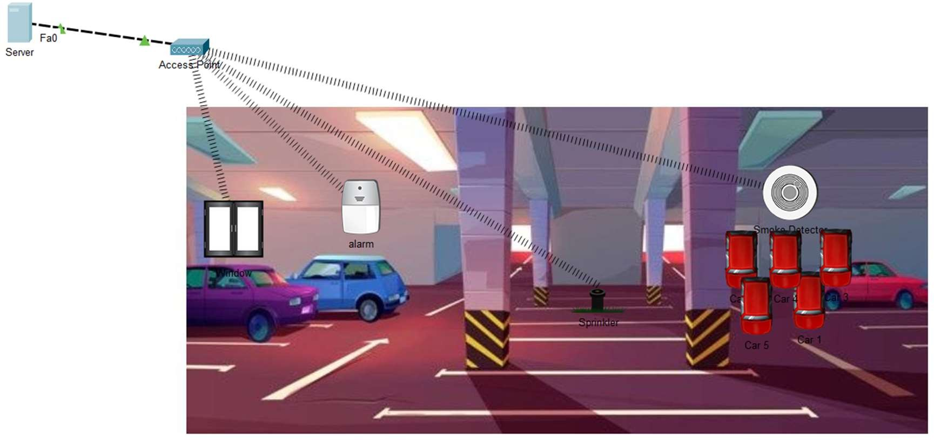

**Step 2:** Set the SSID as “Cisco” for Access Point0.

**Step 3:** Connect the server to the access point using Copper Cross-over Cable through the Fa0/0 interface.

**Step 4:** Connect all the IOT devices to the Access point wirelessly by specifying the SSID as “Cisco”

**Step 5:** To set up the registration server follow:

* Desktop Tab => Browser
* Type the URL as (http://192.168.1.1), then click on Sign up
* Set your desired user name and password

**Step 6:** Login to the registration server using the credentials set in the previous step.

**Step 7:** Add conditions for the IOT devices using the smoke detector as the trigger.

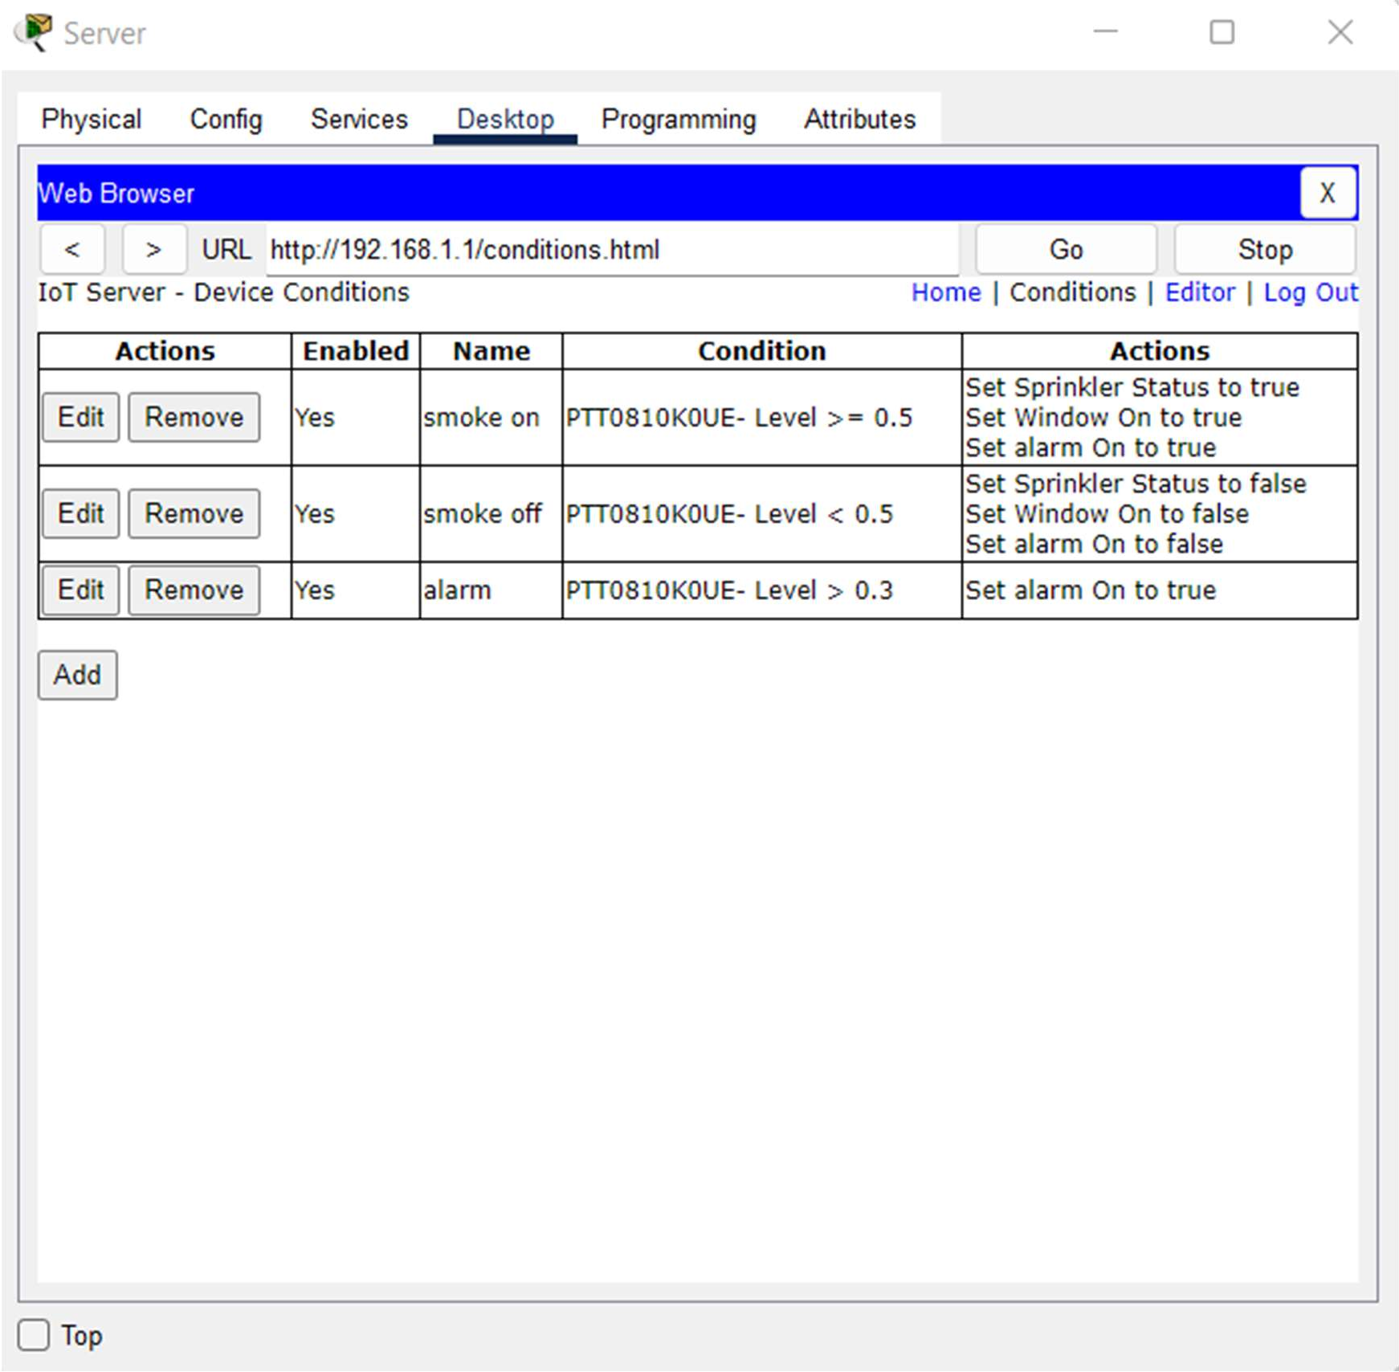

**Step 8:** Test the system using the cars to trigger the smoke detector.

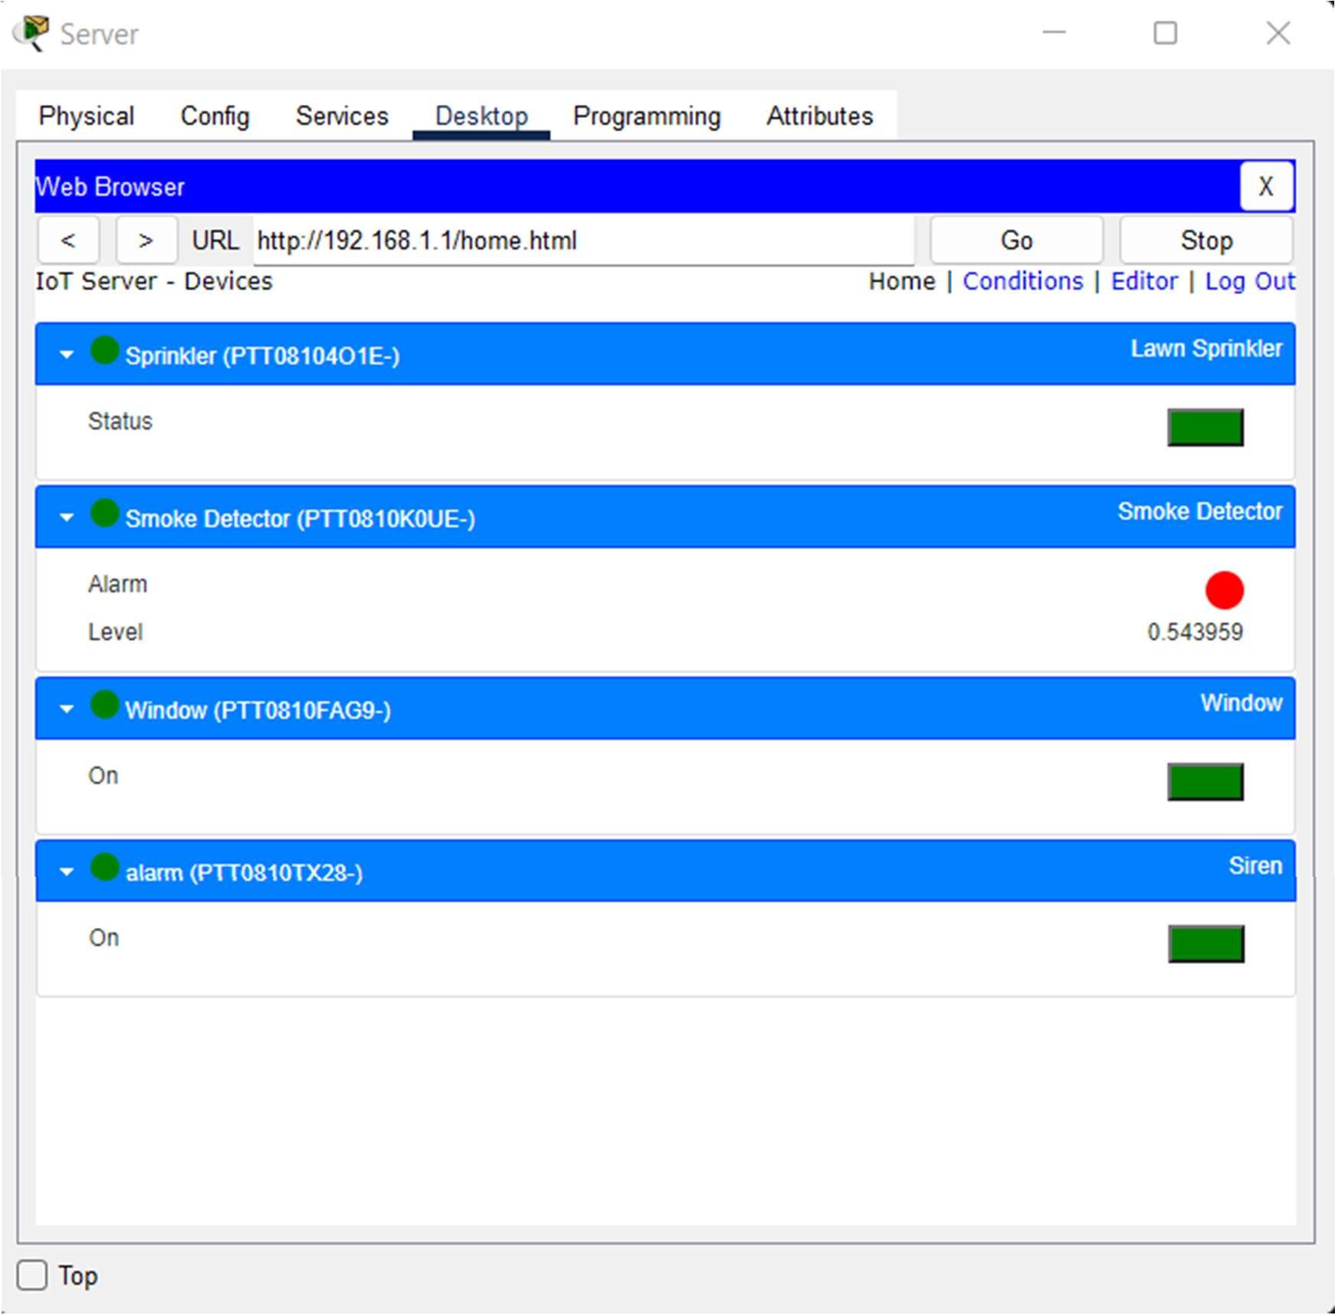

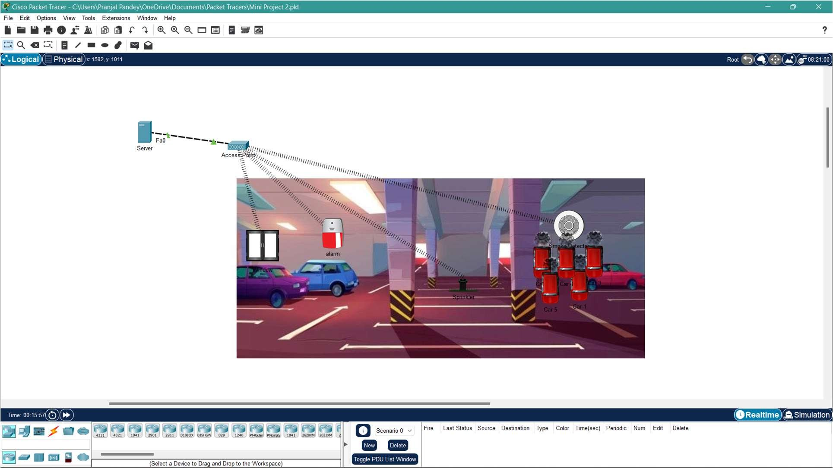

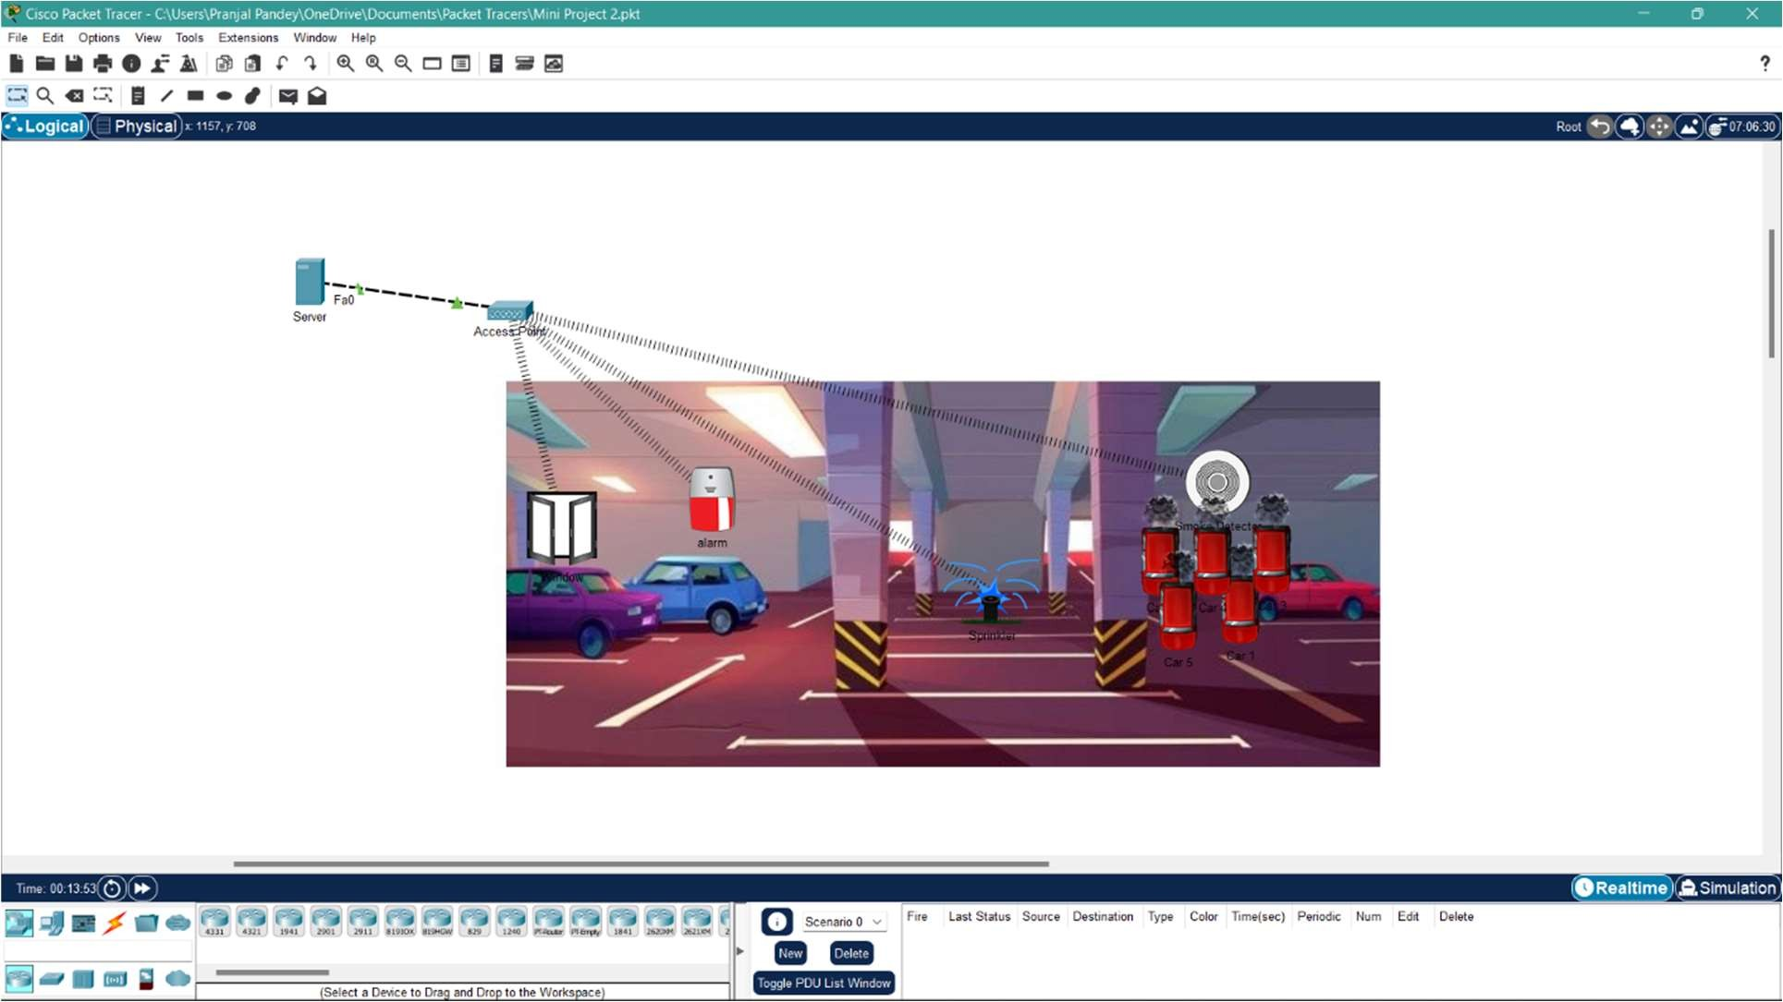

# Result:

The fire prevention system has been successfully constructed and tested.